**Hybrid Automation Framework**

This is a test automation framework developed for the problem statement given by Nintex for writing test cases for the below scenario.

**Scenario**

The trainline.com website (<https://www.thetrainline.com>) has implemented a feature to enable one-way train booking. As a user, I would like to be able to search for one way tickets from one city to another so that I can evaluate the departure time and also ticket prices.

**About Framework**

I have designed a Hybrid Automation Framework to test the above scenario to design this framework I am using **Thoughworks Gauge** + **Selenium WebDriver** libraries.

**Prerequisites**

* Install Java
* Configure Maven
* Install Gauge
* Install Gauge plugins
  + - Java
    - html-report
    - screenshot

### Installation

1. Install Gauge

Download the [zip](https://github.com/getgauge/gauge/releases/download/v1.0.0/gauge-1.0.0-windows.x86_64.zip) installer and the run following command in powershell.

***PS> Expand-Archive -Path gauge-1.0.0-windows.x86_64.zip -DestinationPath custom_path***

Make sure Gauge added in $PATH

1. Install Gauge plugin

* gauge install java
* gauge install html-report
* gauge install screenshot

For any help on installation please refer [link](https://docs.gauge.org/latest/index.html)

### Running the tests

All test cases are under the specs folder.

Run below commands to execute all specification in specs directory.

***mvn test -P{profile} -DspecsDir=specs{optional} -Denv={chrome/firefox/ie}{optional}***

Launch using **Chrome**(default option) with minimum options

***mvn test –Pdev***

Launch using **Firefox**

***mvn test -Pdev -Denv=firefox -DspecsDir=specs***

Launch using **IE**

***mvn test -Pdev -Denv=ie -DspecsDir=specs***

**I have only tested the scripts on Chrome.

Execute specs In **parallel**

***mvn test -Pdev -DspecsDir=specs -DinParallel=true -Dnodes=<No, of Nodes>***

Execute specifications by [tags](http://getgauge.io/documentation/user/current/advanced_readings/execution_types/tagged_execution.html)

***mvn test -Pdev -DspecsDir=specs -Dtags="logIn"***

### Framework details:

* **Specs** (Specifications): In Gauge, we write our test cases as .spec files, I have created 2 test cases(spec):

1. TrainLineHomePage.spec

* Verifying the mandatory fields of Search form
* Verifying the visibility logic and functionality of Swap location button
* Verifying the Past date should not be allowed
* Verifying the minimum and maximum no of passengers allowed
* Verifying that age of child should be greater than 4 if travelling single
* Getting broken links information if any on Home Page
  1. TrainLineSearchResults.spec
  + Verify user able to perform Search and validating the search results
  + Getting broken links information if any on Search Result page
    - **Repository:**

Instead of using typical POM for designing framework. I am maintaining objects, divided by pages in repository.xml

* + - **Drivers :**

Driver folder contains DriverFactory. It allows us to test application with different browsers like Chrome, Firefox and IE. However, I have tested my scripts only with Chrome.

User can pass browser using ***-Denv={browser_name}*** property and configure driver in ***/env/{browser_name}/browser.properties*** folder.

* + - **TestData :**

I have separated my test data from the scripts to make them more re-usable.

TestData is available under src/test/resources

* + - **Reports :**

Html reports are available in report folder

All failed test steps will contain snapshot of the failure

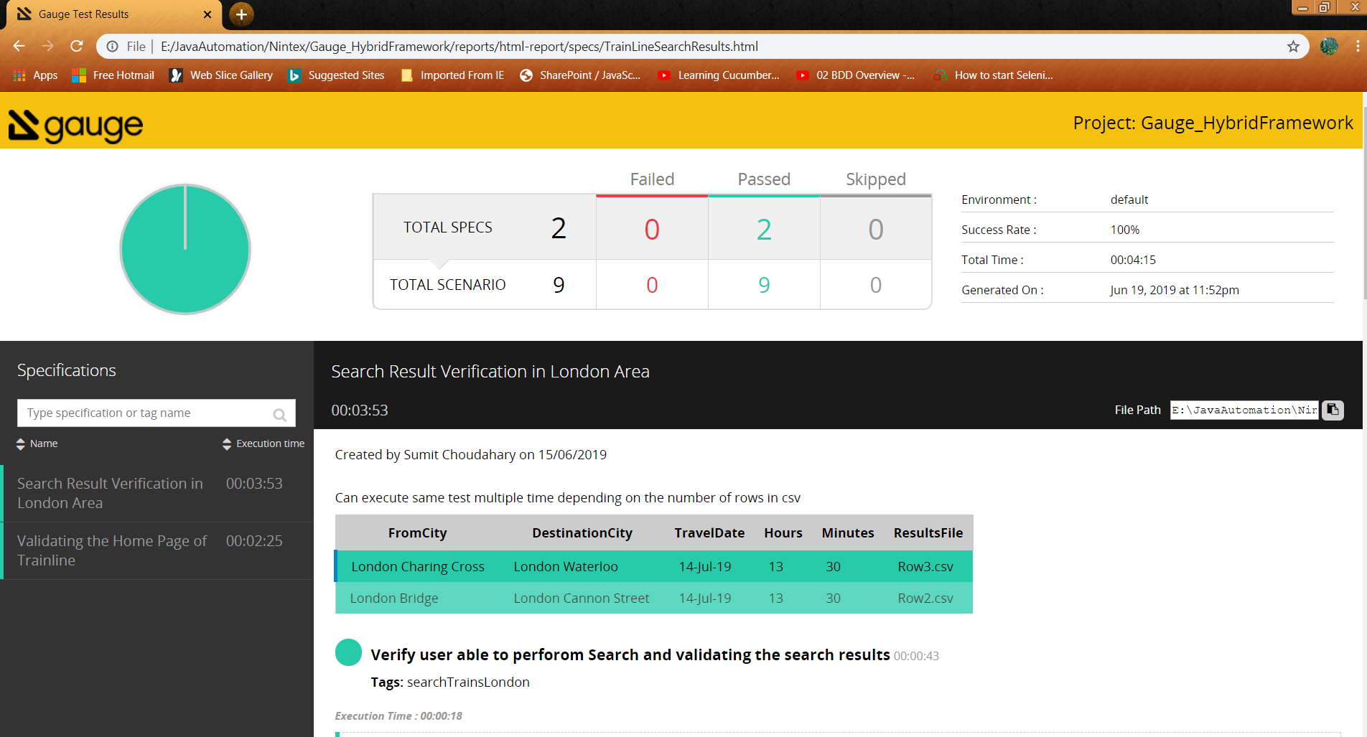

* + - **Logs :**

Generating custom logs under hf_logs/ folders with below 3 logs.

* testhfInfo.log: Contains Info logs
* testhfRegression.log: Contains Debug logs
* testhfError.log: Contains Error, Warn and Fatal

**Author**

Sumit Choudhary